Finding Cohort 4 is tricky because it includes sub sets of coded groups e.g COPD on home oxygen, we might have COPD coded but I doubt very many have on home oxygen coded.  So for some of the patients you will need to use the previously circulated CDM searches to find e.g. COPD and then go through the list and see from your knowledge of patients can you pick out the relevant ones.  If anyone has any suggestions or methods for more specific ways to find relevant patients please do share your ideas.

There are some categories that we can find which I describe below.

**First is HbA1C > 58.**

We can find this using the report

“Investigation Recall”

This is really useful for all sorts of searches, but the screen shot below illustrates how you find HbA1C over 58.  The red areas circled are the only things you must change.  At the top I have just put the last year so as not to get hundreds of previous results, you might prefer to set this to 2 years etc.

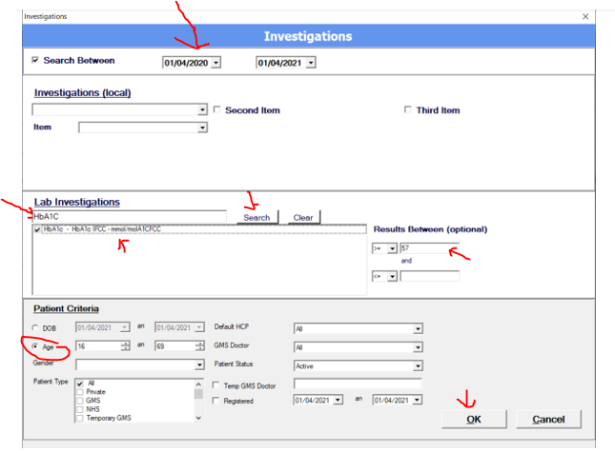

**BMI over 40**

We can also search for BMI over 40 but this is dependent on you having used base line details to record BMI.  Using baseline details is something we might return to in the future.  If you have used it then you can use the report

“Baseline details population” as follows

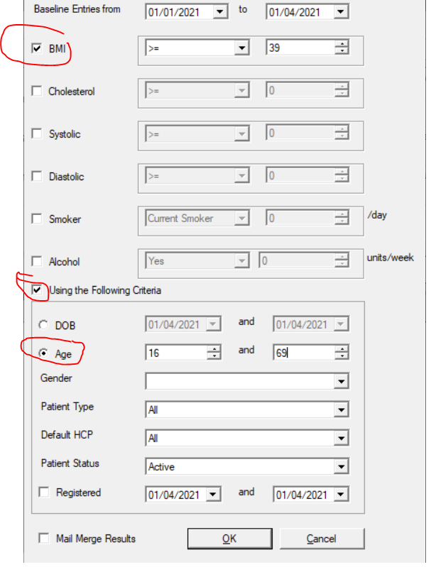

Good luck with the roll out.

Michael