A Guide to participation in the HSE Chronic Disease Management Program for Centric Practices.

As of 20/1/2020 the new Chronic Disease Management (CDM) program is being rolled out. This guide, subject to change as updates are issued, will assist you in participating in the program.

The guide is divided into the following sections

* Summary
* Signing up
* Coding
* Case finding
* Recruitment and follow up
* FAQ’s

**Summary**

Phase 1 – age 75 & over – diagnosis of Type 2 diabetes, Asthma, COPD, Cardiovascular Disease including stable heart failure, ischaemic heart disease, CVA/TIA atrial fibrillation.

Patients who are already registered under the Diabetic Cycle of Care & Heartwatch programme should be transferred to the new programme & the payment for these patients will cease once the first return under the new programmes has been made.

Two scheduled visits required per annum. Anticipated each will require GP & nurse input. Interval of at least 4 months between the visits over a 12 month rolling basis. First visit more detailed than second.

Data to be submitted online & reimbursement will follow on receipt of the data return.

Practice software tool will assist in clearly identifying what data is required which differs for each disease.

Looking to extend the programme and refine the nursing support system.

For Phase 1 – a one off grant will be paid to GPs in the 2nd half of 2020 based on the no of eligible patients aged 75 & over who are registered on the programme & where at least one data return has been submitted by HSE on or before 1st July 2020 – amount payable per patient €28.75.

GPs must sign to opt in and indicate which GP management system you use so that the HSE can communicate to them to provide you with the necessary upgrades to be able to do this work. There is no need to register patients. Once the first return via the PCRS has been made this triggers the payment and the patient will be on the register from this time.

* **Payment structure for 75 or Over – Chronic Disease Management programme**

|  |  |
| --- | --- |
| **Description** | **Annual Amount** |
| 1 chronic condition | €210 |
| 2 chronic conditions | €250 |
| 3 or more chronic conditions | €300 |

Each data return will generate reimbursement of 50% of the annual fee. Payments qualify for superannuation purposes.

Cardiovascular diseases are deemed to be one chronic disease.

**Signing Up**

All GMS contract holders should have received a circular in the post. It is a simple matter to complete and sign the form and return it to the HSE using the included instructions.

**Coding**

How to code for the CDM programme in each of the Clanwilliam softwares. The programme uses ICD10 codes.

The codes are

|  |  |  |
| --- | --- | --- |
| **Condition** | **ICD10** | **Health One Dictionary term** |
| Asthma | J45 | Asthma |
| Atrial Fibrillation | i48 | Atrial Fibrillation |
| Hypertension | i10 | Hypertension |
| Diabetes Type 2 | E11 | Diabetes Mellitus type 2 |
| Ischaemic Heart Disease | i25 | Ischaemic Heart Disease |
| COPD | J44 | Chronic obstructive airways disease |
| Heart Failure | i50 | Congestive heart failure |
| Cerebrovascular disease | i67.9 | Cerebrovascular accident |

**Socrates**

Your practice manager should have set up these note templates for you. If they are not available ask the practice manager or contact [mjoyce@centrichealthblessington.ie](mailto:mjoyce@centrichealthblessington.ie) .

Go to Consultation on the left hand side then open patient, search for the patient, in my example case, John James Test.

Open the patient and create a new consultation

Click on start consultation on the left, once consultation has started click on notes. I will describe how to enter asthma but the process is the same for the other conditions.

You should see this screen

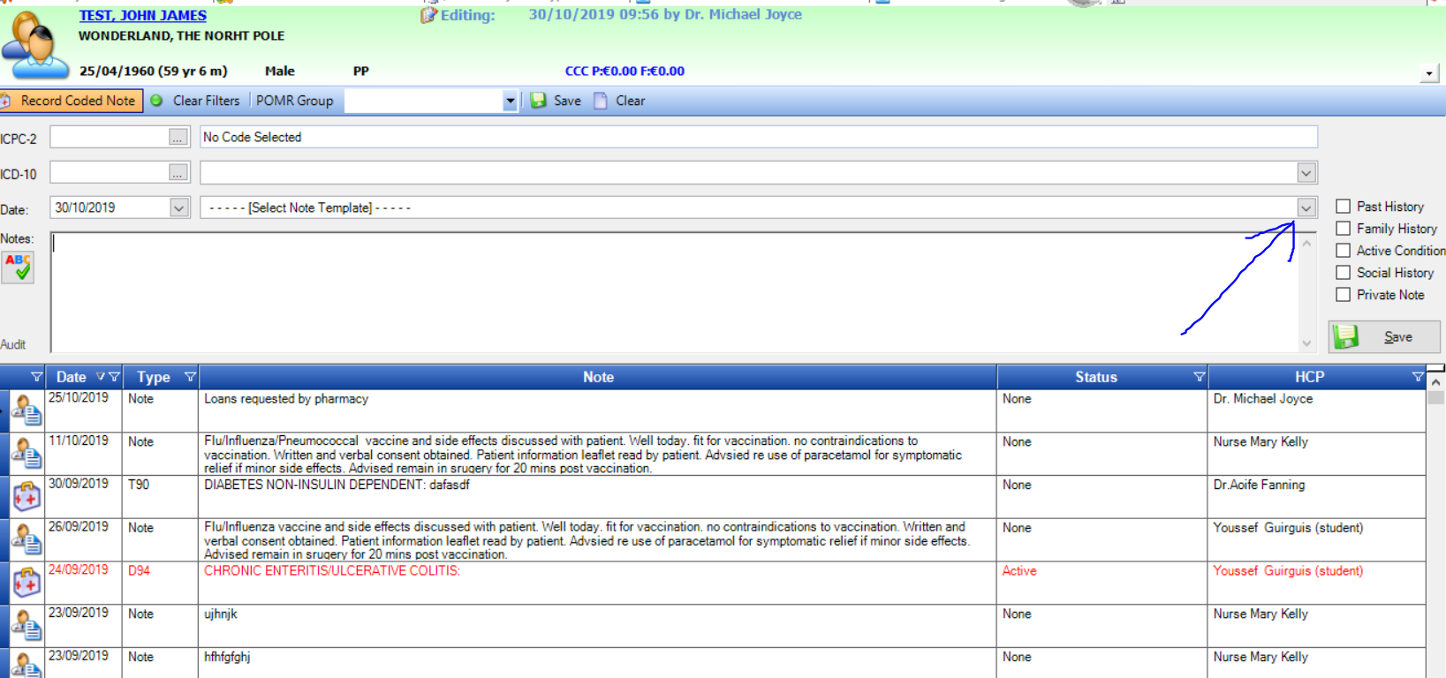

Click on the down arrow in the line that says select note template and find asthma

You can shorten the list by pressing the first letter of the template on the keyboard, in this case “a”

Click on the asthma line, this enters the relevant template.

Now click on the active condition button to make it an active condition and click save.

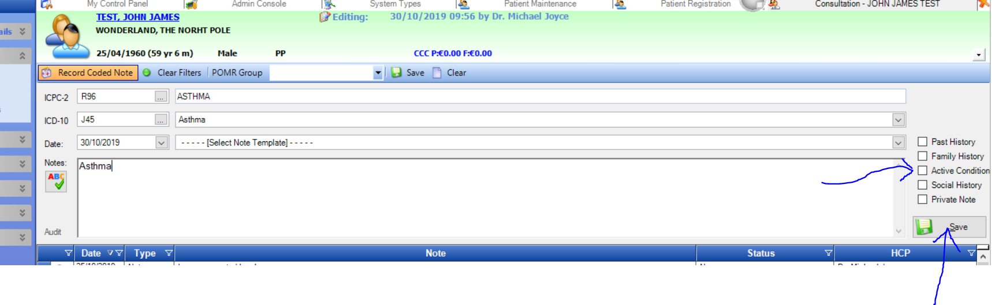

Making a code active means it will appear in the summary screen and will be picked up as a medical history item in letters etc.

Do not add anything more to this note. To enter further notes today use a new note.

**Health One**

Use the item called problem and enter it in the Basic Medical Information page.

If there is no Basic Medical page set up add it by pressing this button. Pressing this button bring you to the Basic Medical Information if it already exists

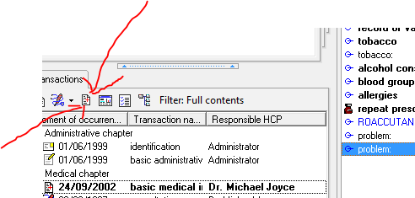

If the item problem is not immediately available simply type the first few letters and choose problem from the list

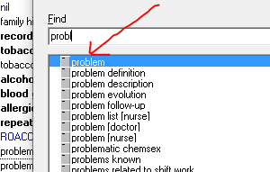

Look for the condition you want to enter as a coded item in the associated list or if the term is not in the associated list or there is no associated list look in the “blue book”.

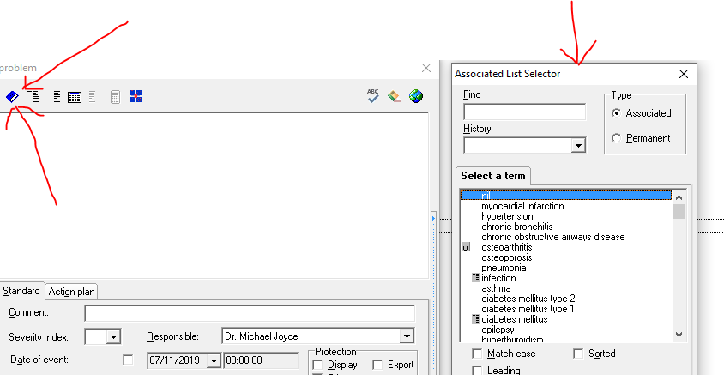

Pick the term from the list. Health One automatically codes in the background in both ICPC and ICD10 when you pick the word from the list.

**HPM**

Open a patient file in HPM and click on the Add New button the Medical history box on the health summary screen or from the ribbon –

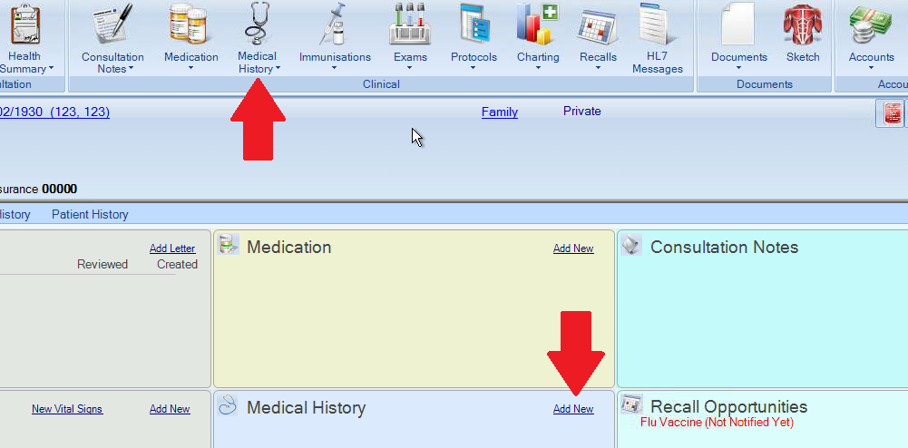

A search box will appear, you can choose which coding you wan to make your from the drop down at the top – either ICD or ICPC. If you leave this on default it will search both.

In the search box begin typing the diagnosis –

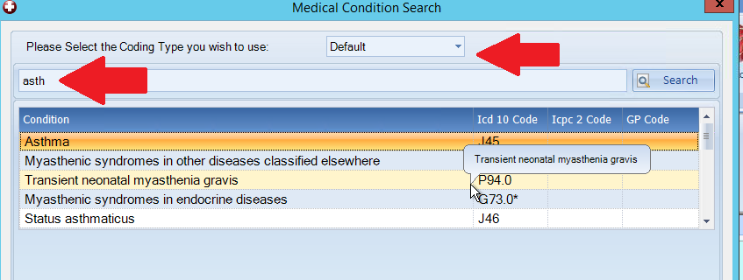

Once the diagnois has been select the following screen will appear – the active box is ticked by default this will ensure it will appear on the health summary screen. The Chronic tick is also selected by default.

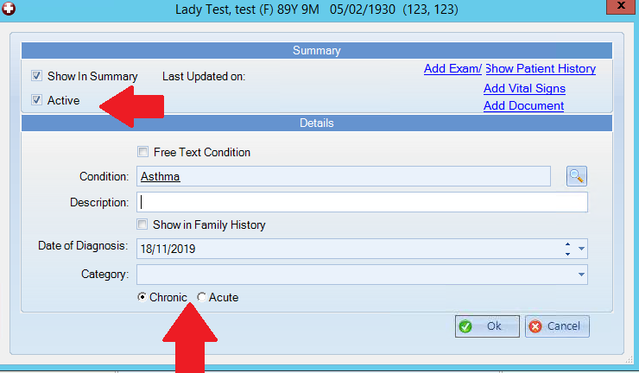

The above medical history screen can also be accessed from the consultation note –

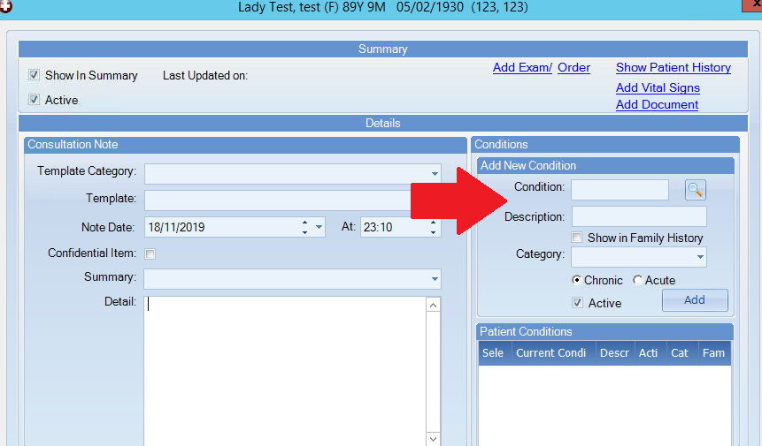

**Case Finding**

The objective is to identify patients who qualify for participation in the programme.

I will first describe how to run the report to see how many potential patients you have. We would like you to record this number before proceeding to the second step of finding any non-coded patients. Once the potential list is produced it should be reviewed by a doctor who will confirm the patient meets the criteria for inclusion and you can proceed to invite the patients in for their first visit.

For 2020 this includes patients aged 75 or over who have one or more of the qualifying conditions.

Please note this section in particular maybe subject to change as Clanwilliam may provide new tools to accomplish this task. When they do this document will be updated.

Step I

Identify coded patients

Socrates:

Diabetes: In reports section go to IPCRN tools and pick the Diabetes tab then run the “Diabetic Register” report. On the opening dialogue enter the age range 75 to 100. As the majority of these patients will have a medical card it is ok to leave patient types as all. Click OK.

The report will generate. Print the report to give to the doctor. The doctor should study the list and remove any patients that are unsuitable for the CDM programme. The remaining patients can be invited to attend for a first visit.

Other conditions:

In the general reports section there are two very useful searches for this purpose. They are in the Patients section and are called “Patients with a certain condition” and “Patients with multiple conditions”. They are similar to each other but one allows a search on just one condition while the other allows for searching several conditions at once. Either will work for what we want to achieve. Below is a screen shot of a search for all the CDM conditions with the exception of diabetes.

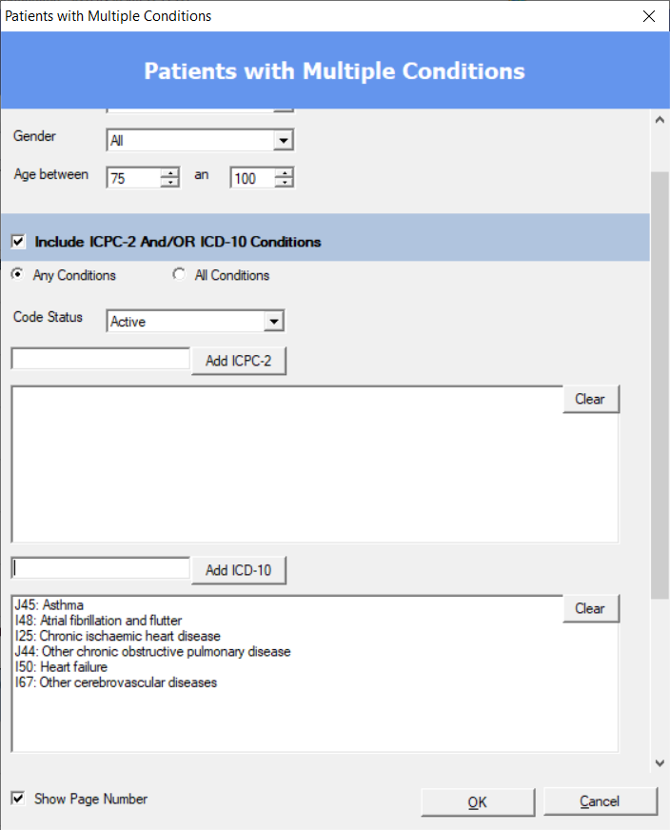

It would be of interest to record how many patients you can identify before moving on to step 2 to see how many extra cases you find during the case finding process.

Health One:

There may yet be a new search provided when the CDM software is released. Until then use your diabetes cycle of care information to identify our diabetic patients.

For the other conditions

Open and write a new search as below. Click on analysis, then database (query plus)

Click on New and call it CDM

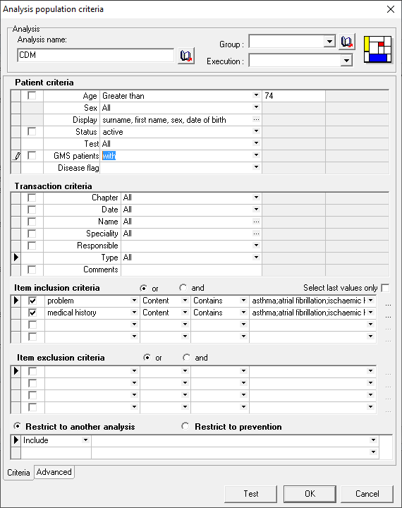

The line that you can’t see all of reads – you can copy and paste it from here

asthma;atrial fibrillation;ischaemic heart disease;heart failure;cerebrovascular disease;chronic obstructive airways disease;myocardial infarction

This should produce a list of your eligible patients.

It would be of interest to record how many patients you can identify before moving on to step 2 to see how many extra cases you find during the case finding process.

HPM

Instructions awaited.

Step 2

Depending on how well disease coding has been carried out to date you may need to find eligible patients that are not yet coded. There are a few ways this can be achieved.

1: Opportunistically. As patients have contact with the practice e.g. repeat prescriptions, other appointments or hospital reports coming in everyone involved should pay attention to picking up if any of them have the relevant eligible conditions. When discovered they should be coded. It would be good practice to start doing this now for all age groups as the qualifying age groups will expand next year and beyond.

2: Personal knowledge: It is likely the doctors will be able to identify from memory at least some patient who have the qualifying conditions.

3: Specific drug searches:

Probable to most efficient way to identify eligible patients is to search patients who are on particular drugs which are commonly used in the conditions, e.g. DOACs for atrial fibrillation. However the lists will not always be completely accurate so nce produced they need to be reviewed by a doctor to confirm the diagnosis and then they can be coded.

Again the searches depend on which software you have. The best method is to search using drug ATC codes. Each software will again require different instructions but the ATC codes are the same for all. Suggested ATC codes to use are as follows.

To find possible atrial fibrillation cases:

Antithrombotic agents

B01A +

F for DOACS

A for vit K antagonists

To find possible Asthma and COPD patients

Respiratory System

R03B +

B for LAMAs

A for inhaled steooids

R03A +

S For bronchodilators

Cardiovascular System

Possible stent patients in the last year – platelet aggregation inhibitors

B01AC

Other possible drugs to search

Aspirin is N02BA01

Bisoprolol is C07AB07

All diuretics C03

Frusemide is C03CA01

Spirolactone C03DA01

Socrates

The report to search drugs using ATC codes is in the prescriptions section called “Socrates search”

It’s a slightly cluttered looking screen but looking at using B01A – antithrombotics i.e. looking for atrial fibrillation.

See picture below, enter atc codes as shown then click add. Limit your criteria i.e. age and also for patient type click all gms categories ( or in this case I have ticked all)

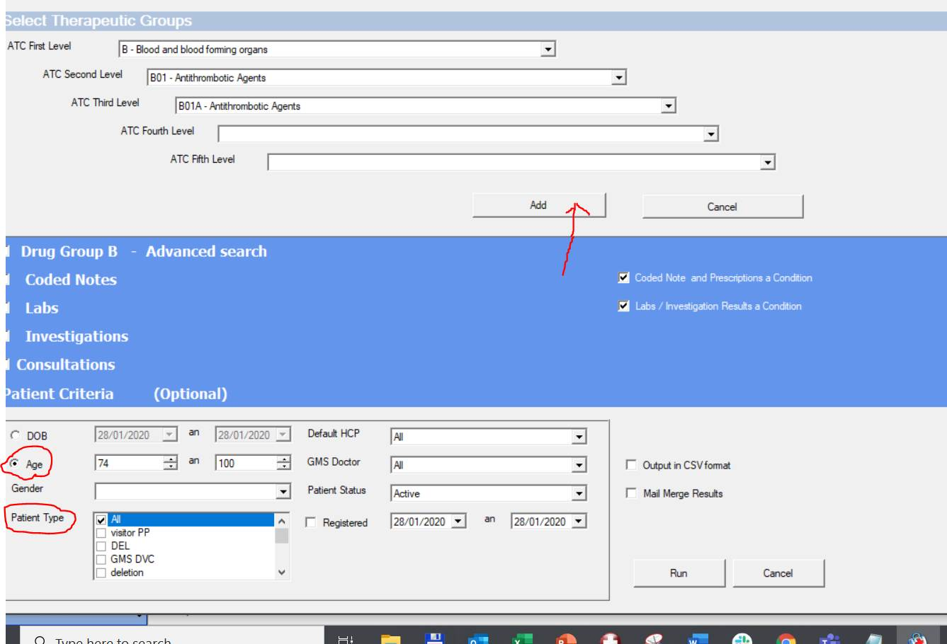

Health One

Write the search as follows for searching on ATC codes.

Change the ATC code for each search you wish to run.

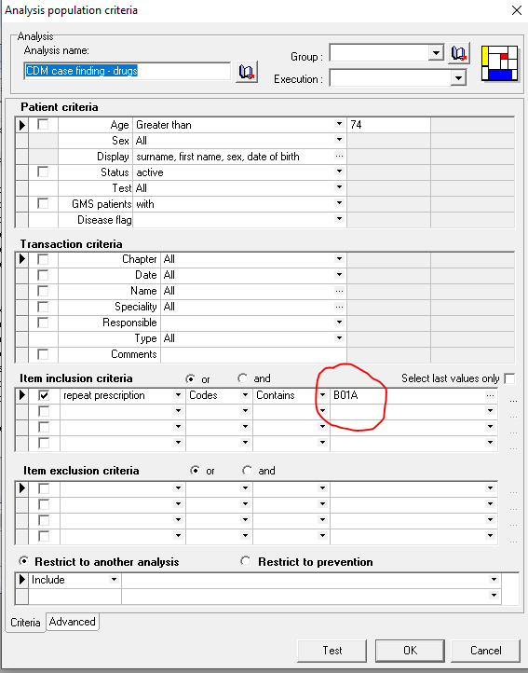

**First visit and follow up**

Practices should decide locally how best to achieve this. In general the list of eligible patients should be used to call people into appointments in an organised fashion. The first visit should be with the nurse and should include the taking of bloods. A follow up visit for 7 to 10 days later with the GP should be organised. Once the first visit is complete a recall schedule should be set up. When the recall is due the process can be repeated.

**FAQ’s**

**What happens when we have no access locally to BNP testing/echo/spirometry?**

If any required data is unavailable locally enter “not available” and this will be accepted.

**What happens if the patient is already in the diabetic cycle of care?**

Once you submit a first visit return for a patient registered with cycle of care that patient will automatically be removed from the diabetic cycle of car program. There will be no need to do any further cycle of care visits or returns for that patient.

**What happens if the patient is already in the Heartwatch program?**

The CDM program replaces the Heartwatch program so once in the CDM program you should no longer make Heartwatch returns for that patient. In the case of Heartwatch this does not happen automatically.

**Who can I contact for help?**

Centric is here to help. The following people should be able to assist you with any difficulties or questions. Your practice manager, your regional manager, your nurse lead, Marion Mulchay [mmulcahy@centrichealth.ie](mailto:mmulcahy@centrichealth.ie) ,your GP lead or Michael Joyce [mjoyce@centrichealthblessington.ie](mailto:mjoyce@centrichealthblessington.ie)

Clanwilliam support can assist with software enquiries.