It is time to be thinking about your Audit for 2023/24.

One that might be of interest to you is one of the featured audit examples on the ICGP website here:

Familial Hypercholesteremia

The reason I say this is because its relatively easy to do, it is an important topic and in conjunction with our colleagues in Care Connect we may be able to offer a pathway for genetic testing for appropriate patients in the near future.

Initially I will describe how to do the Audit where the objective is to code appropriate patients so that they can later be found easily.

Audit Question: How many of our patients who potentially have familial hypercholesteremia are correctly coded?

The ICD10 code I choose to use is E78.0.

Before we start we will measure how many of our patients are currently coded with E78.0.

To do this use the report “Patients with a Certain Condition”.
1: Choose ICD10
2: Search for and confirm E78.0
3: The code should appear here
4: Click OK to find all patients with the code
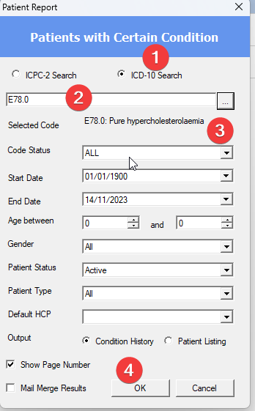

The next phase of the audit is to find patients who potentially have familial hypercholesterolaemia.

You can do this using the report “Investigation recall”
1: Type LDL in the Lab Investigations section
2: Click Search
3: All lab investigations with LDL in the name will appear here, in the example there is only one but often there are several here which should all be checked.
4: Put 5 here so that the search is for all patients with an LDL of 5 or greater
5: Click OK
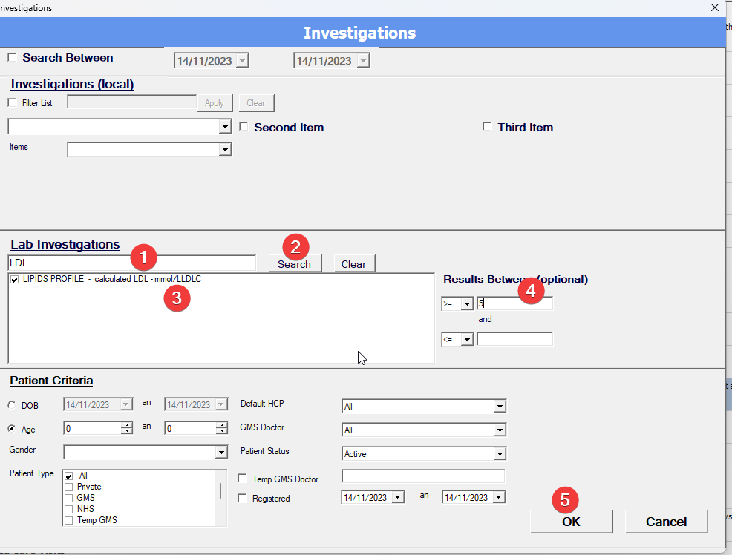

This will produce a list of patients who have ever had an LDL result of 5 or higher.
You can now study this list and determine if these patients should be coded as E78.0.
For the intervention then, we will code those patients that we consider are appropriate to be so coded.
In the second arm we will then measure how many patients are now coded. This is a good outcome because now if a service emerges that could offer genetic testing to appropriate patients, we could quickly find the potentially eligible patients. This is of course in addition to treating their raised LDL appropriately.

Some additional Information
One thing to note is that diagnosis is made on untreated levels of LDL. This audit is assuming that even those who are on treatment who might now have an LDL below 5, will have had a pre-treatment reading of over 5.
There is a useful tool available here to work out what an untreated level would be for those that are on treatment.

https://www.lipidtools.com/calculator-pages/ldlc/

It looks like this:

1: Put in the treated level of LDL
2: Click Untreated
3: Pick which statin they are on
4: Pick dose they are on
5: If on any of these click Yes
6: The expected untreated LDL level is displayed.

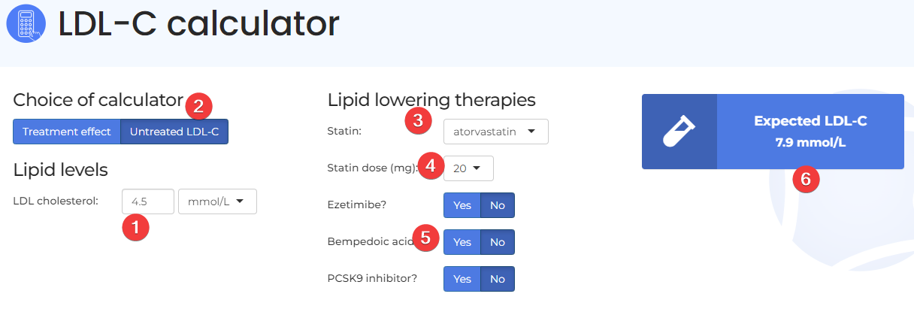

The Dutch Lipid Clinic Network Score

You can do the audit based on just the coding but if you wish to go an extra step her you can see how you may calculate a DLCN score.
This is a score used to calculate the likelihood a patient has familial hypercholesterolaemia. There are several sites available to help calculate it. Here is a typical one:
https://www.lipidtools.com/calculator-pages/dlcn/
Obviously, you will need to interview the patient to be able to gather the necessary information to calculate the score.
It works like this:
1: When you start all the answers are no by default, click any relevant yes’s.
2: Enter the untreated LDL
3: The score appears here
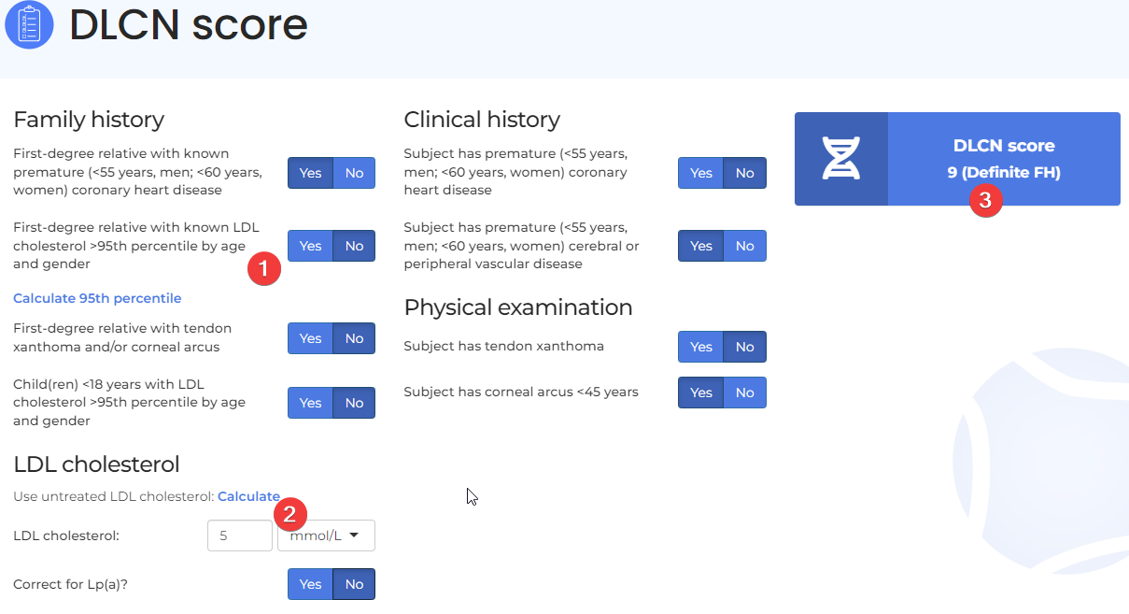

If genetic testing becomes available, we will need to carry out a DLCN score on them. By way of example, a sample referral form for St James’s hospital to request genetic testing for a familial dyslipidaemia can be found here:
https://www.stjames.ie/media/SJH%20FH%20Genetics%20request%20and%20consent%20form%20revision%202.pdf

